Victoria Beegle, Josh Martinez, Clay Suttner, and Charles Sy

Professor Bansenauer

BIT 271 - Mobile UI Design

11/11/2019

Project-Design

* **MVP Features:**
  + Find OrcaStars businesses nearby via current location
    - Map zooms to yield significant results
  + Search manually
    - Type-in a manual term to search for
    - Refine search with categorical filters, including
      * Restaurants
      * Bar & Nightlife
      * Health & Medical
      * Shopping
      * Automotive
      * Home Maintenance
      * Professional Services
    - Sort results
      * By popularity
      * By OrcaStars Tenure
      * By proximity to you
  + View more about a result, including
    - Contact and Location information
    - OrcaStars Tenure
    - Practices for sustainability
    - Hours of operation
    - Link to website if available
  + Ability to add business to “Favorites”
  + Learn more in the “About” sections
    - About the OrcaStars program
      * Requirements for OrcaStars certification
    - The Orca Conservancy itself
* **Updated Scenarios, User Stories and Flow Diagrams:**
  + **Scenario 1:** 
    - Anise is a marine biologist. She loves marine life, and ever since she was little, *Orcinus orca* has been her favorite. She’s always upset when she sees in the news that more animals have died from eating or choking on plastic. She wants to take a stand and stop supporting the companies that contribute to this, but she doesn’t know of any nearby places that focus on sustainability to protect animals like her beloved orcas. She wants an app that can tell her what businesses around her location are dedicated to preserving the environment.
    - **User Story 1:**
      * User Story 1-A:
        + As an orca lover, I want to find businesses that focus on sustainable practices so that I avoid supporting businesses that don’t.
        + Use Case 1-A:

User chooses Find Near Me

OrcaStars App sends business locations to Google Maps app

Google Maps is opened inside OrcaStar App

OrcaStars App displays Google Maps with all business locations marked

* + - * User Story 1-B:
        + As a marine biologist, I want to know what businesses near me practice sustainability so that I can support them and their efforts
        + Use Case 1-B:

User chooses Find Near Me

OrcaStars App sends business locations to Google Maps app

Google Maps is opened inside OrcaStar App

OrcaStar App displays Google Maps with all business locations marked

* + **Scenario 2:**
    - Logan is a highschool student whose highschool recently got nominated by OrcaStars for their “Go Green” program. He wants to learn more about his local businesses, so that he can support the ones that focus on sustainability. He doesn’t have the time to visit all of them individually, either in person or on their website, to know if they are part of OrcaStars. He wants to be able to easily search through OrcaStars businesses, and learn what each one does for the environment to preserve the orca population.
    - **User Story 2:**
      * User Story 2-A:
        + As a highschool student, I want to easily learn more about my local businesses so that I know what each one does for the environment.
        + Use Case 2-A:

Search for specific business in the app top bar

App returns list of businesses with matching name

User selects specific result

App returns information about business’s sustainable practices

* + - * User Story 2-B:
        + As a student of a nominated highschool, I want to know more about how each business contributes so that I can identify businesses with the most room for improvement.
        + Use Case 2-B:

Search for specific business in the app toolbar

App returns search with matching businesses

User clicks on the matching business

App returns business information

* + **Scenario 3:**
    - Despite frequenting The Green Bean, a carbon-neutral cafe, Mike knows that he could probably contribute to a sustainable future in more impactful ways. Noticing a flyer at his preferred coffee establishment, he scans a QR code, taking him to the App/Play Store where he downloads OrcaStars. Curious what a zero emissions latte has to do with *Orcinus orca*, he navigates to the “About” section on his device. Mike scrolls through information about Orca Conservancy and the OrcaStars program, has his questions answered, and is excited to check out other OrcaStars businesses.
    - **User Story 3:**
      * User Story 3-A:
        + As a frequent supporter of an OrcaStars business, I want to learn about Orca Conservancy so that I can understand how I’m influencing the environment with my spending.
        + Use Case 3-A:

User opens OrcaStars App

They tap the question mark icon on the app homepage

App switches to “About” activity

“About Orca Conservancy” selected

OrcaConservancyInfo fragment runs

* + - * User Story 3-B:
        + As someone who knows nothing about the OrcaStars program, I want to see what commitments it requires of its members so that I can
        + Use Case 3-B:

User opens OrcaStars App

They tap the question mark icon on the app homepage

App switches to “About” activity

“About Orca Stars” selected

OrcaStarsInfo fragment runs

* **Paper Prototypes/Test Results:**
  + **Images:**

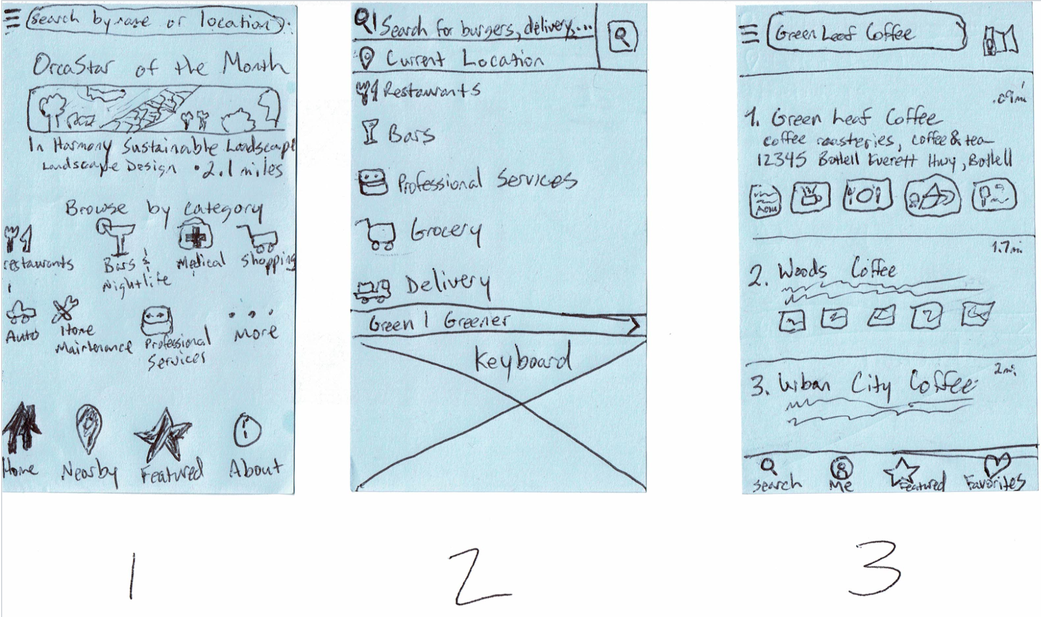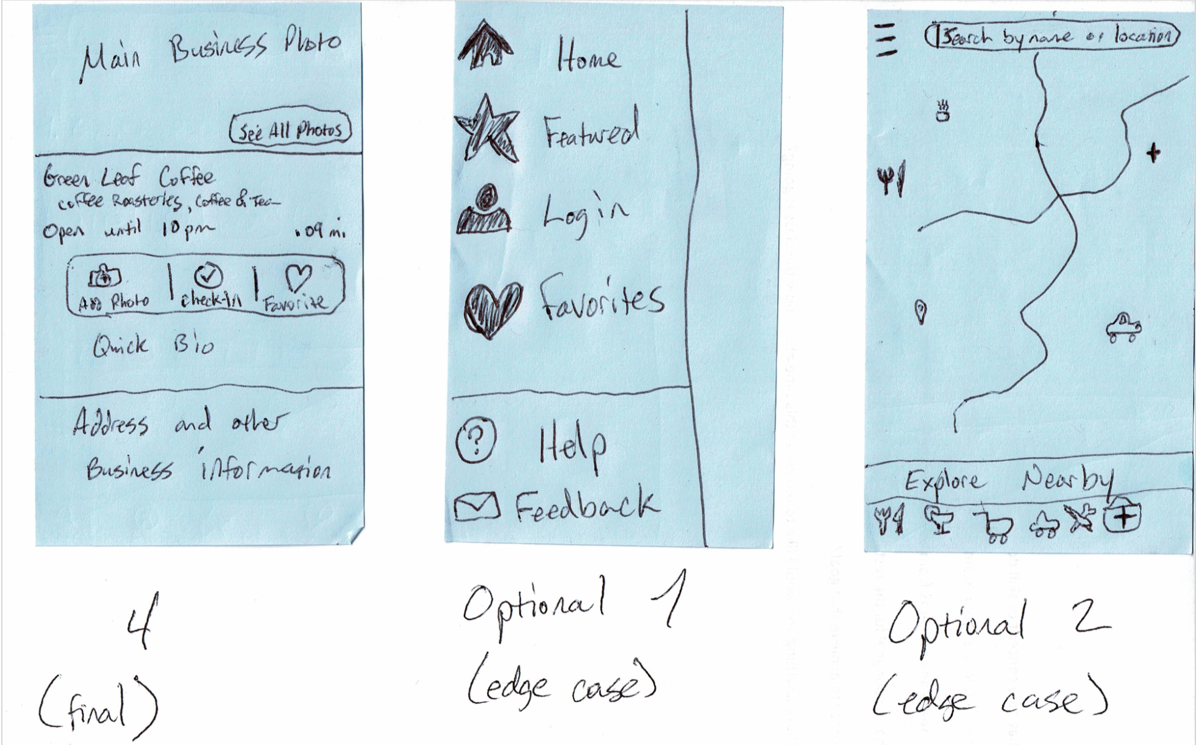

* + **Test Results: User Story 1-A**

**User: Brandy**

* User was a little overwhelmed with the home screen. She was happy with the amount of features and options, but felt that the search bar at the top is lost with everything going on. She suggest maybe just a list of categories that, when selected, takes the user to a list of businesses within said category (ie. clicking on bars and nightlife will take the user to a list of businesses that fall into that category, with the option to switch from list view to map view).
* User tried clicking on categories over the search bar
* User was confused about the OrcaStar of the Month feature
* User was familiar with similar apps (Yelp) and was able to navigate after familiarizing herself with the home screen  
    
   **User: Shelby**
* User was able to navigate easily through the app and also clicked on the map few icon in the prototype search screen, bringing up an edge case.
* User also clicked on the hamburger menu and wanted to know why someone would need an account to sign in if the only option they have to interact with businesses was to favorite them.
* She suggested that the search view have a map showing current location with a search bar on top, rather than a list or category view  
    
   **User: Joel**
* User also felt like the home screen had too much going on and that the search bar on top got lost.
* User prefers to search by category
* User likes to see a map view when searching, thinks the category list on the search screen is redundant.
* User didn’t see the need for a pop out menu for signing in when most of those features were displayed on the bottom
* Suggested maybe adding an option in the bottom app bar, next to about icon, to login and other secondary functions.
* Said it looked too much like yelp without the reviews.
* User was disappointed to hear that there wasn’t going to be a ratings system, being an avid yelper himself.
* **Digital Prototypes/Test Results:**
  + **Images:**
    - <https://marvelapp.com/project/4505681/>

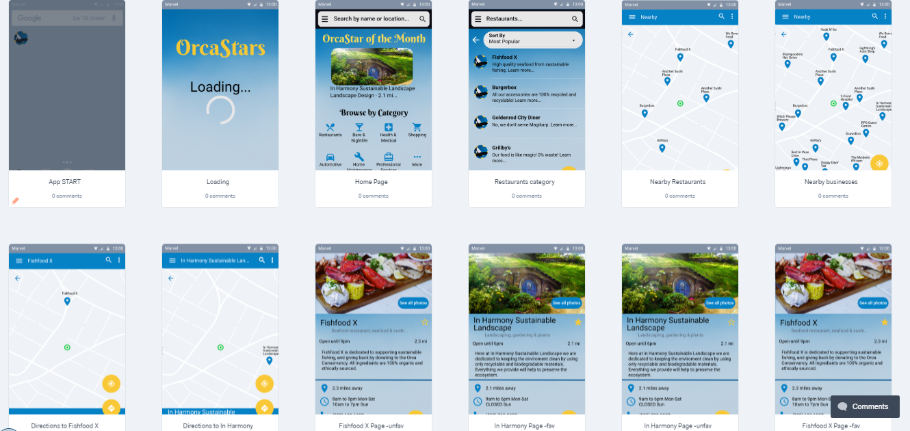

* + **Test Results:**
    - [Pending....]
* **Color Palette:**
  + 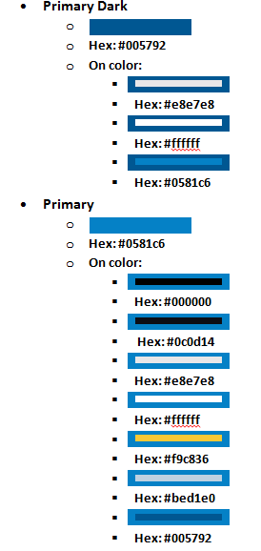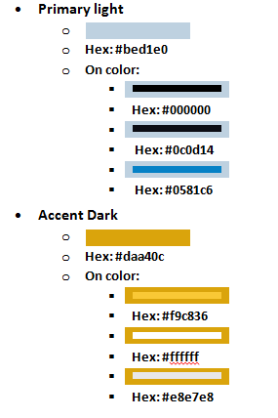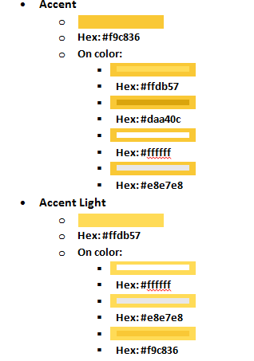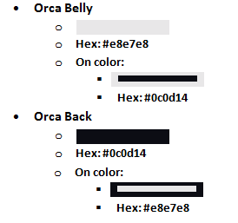
* **Icons for App Navigation:**
  + 
* **App Launcher Icon:**
  + 